AUTHORISATION
NHSGG&C PGD & Non-medical Prescribing Sub-Committee of ADTC
Chairman  in BLOCK CAPITALS | Signature: | Date:
Dr Craig Harrow |  | 15/01/2024

NHSGG&C PGD Sub-Committee of ADTC
Lead Nurse, North Sector, NHS GG&C  in BLOCK CAPITALS | Signature: | Date:
John Carson | 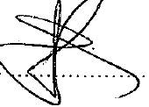 | 15/01/2024

Pharmacist representative of PGD & Non-Medical Sub-Committee of ADTC
Name:  in BLOCK CAPITALS | Signature: | Date:
Elaine Paton |  | 15/01/2024

